University of Waterloo
Faculty of Engineering
Department of Electrical and Computer Engineering
Title of Report
Self-study
Employer Name
City, Province/State, Country
Prepared by
Douglas Wilhelm Harder
20NNNNNN
dwharder@uwaterloo.ca
NX Electrical or Computer Engineering
1 July 1867
Confidential-1

Your address
Your City, Province, Country
Postal Code
July 1, 1867
Vincent Gaudet, Chair
Electrical and Computer Engineering
University of Waterloo
Waterloo, Ontario
N2L 3G1
Dear Sir,
This report, entitled “Title of Report”, was prepared as my NX Work Report for the University of Waterloo. This report is in fulfillment of the course WKRPT n01. The purpose of this report is... . It is a self-study and confidential-1 report.
This is a one- or two-sentence paragraph describing the activities and objects of your employer.
This is a one- or two-sentence paragraph describing the group or department with whom you were employed, your manager, and the objects of that group. This report was written for ... .
An acknowledgment of any assistance you received. I hereby confirm that I have received no further help other than what is mentioned above in writing this report. I also confirm this report has not been previously submitted for academic credit at this or any other academic institution.
Sincerely,
Your name
ID 20NNNNNN

Contributions
This is a self-study report not related to my employment. During my co-op work placement, I was employed at … in the position of …. The team I worked with was relatively small or large... . It falls within the X group. It consisted of N people. Throughout the work placement, I was worked on projects A, B and C.
The team's main goal or goals were... .
My task or tasks were... . or My task or tasks consisted of... .
The relationship between this report and my job... .
In the broader scheme of things, ... .

Summary
The main purpose of the report is to ….
The major points documented/covered in this report are ….
The major conclusions in this report are ….
The major recommendations in this report are ….

Table of Contents
Contributions iii
Summary iv
List of Figures vi
List of Tables vii
1 Introduction 1
1.1 Subsection 1
1.2 Another Sub-section 2
1.3 A third Sub-section 2
2 Background 2
3 The Engineering Problem 2
4 Requirements, Criteria and Metrics 2
5 Possible Solutions 3
5.1 Solution 1 3
5.2 Solution 2 3
5.3 Solution 3 3
6 Engineering Analysis 3
7 Conclusions 4
8 Recommendations 5
Glossary 6
Appendix A : Title of the First Appendix 8
A.1 A Section within the Appendix 8
Appendix B : Another Appendix… 9

List of Figures
Figure 1. 16-year-old white wine. 1

List of Tables
Table 1. A poorly displayed table of data. 2
Table 2. A reasonable display of data. 2

- Introduction
This is the introduction. This paragraph must introduce the report and but also introduce this section. For more information on creating this document, see the report on “Engineering report writing using Word 2010”. [1]
  - Subsection
Some more text and a cross reference to Appendix A and remember that one can lie about statistics [2].
    - Sub-subsection
This section will demonstrate figures. Figure 1 shows the result of storing a bottle of white wine for sixteen years.
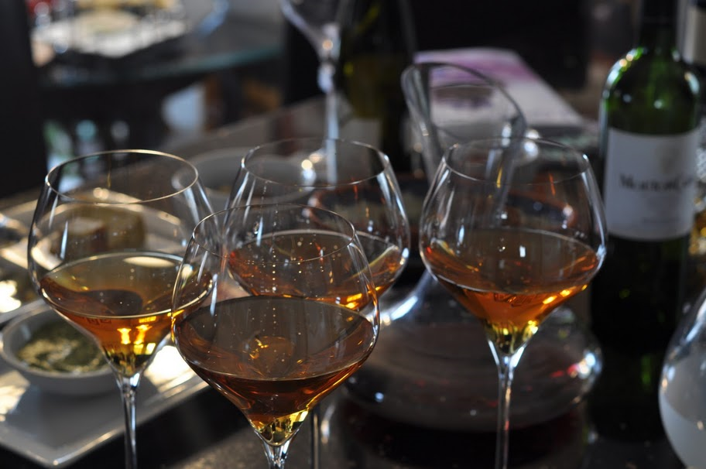
Figure 1. 16-year-old white wine.
The wine becomes deeper in colour going from a light yellow to golden.
    - Another Sub-subsection
Some more text. As a demonstration of tables, Table 1 demonstrates how certain types of entries should not appear in a table. Read on for a better description of tables.

Table 1. A poorly displayed table of data.
 | Integers | Boolean | Monetary | Text | Amount
Row 1 | 3 | T | 12.34 | First class | 0.1234 g/mL
Row 2 | 9 | F | 5.67 | Some more text | 5.67 g/mL
Row 3 | 23 | F | 890.12 | Other text | 89.01 g/mL
Row 4 | 157 | T | 34.56 | Even more text | 2345.6 g/mL
  - Another Sub-section
Some more text.
  - A third Sub-section
Some text and a reference to Appendix B which contains additional information related to this report.
- Background
The background of the report. As another example, Table 2 displays a set of numbers, but are actually the same as that in Table 1.
Table 2. A reasonable display of data.
 | Integers | Boolean | Monetary | Text | Amount  (g/mL)
Row 1 | 3 | T | 12.34 | First class | 0.1234
Row 2 | 9 | F | 5.67 | Some more text | 5.67
Row 3 | 23 | F | 890.12 | Other text | 89.01
Row 4 | 157 | T | 34.56 | Even more text | 2345.6

- The Engineering Problem
Some more text.
- Requirements, Criteria and Metrics
A list of the requirements, criteria and metrics that will be used in this report together with a discussion on any issues surrounding the selection of these. This is an example of an inline equation: the formula is often taught in first year. The integral, however, is slightly less, as is shown by the display equation
.
This is of course centred.
- Possible Solutions
Equations can be numbered, for example, it may be necessary to refer to
,
that is, Newton’s second law, elsewhere in the document. Cut-and-paste this table if you require an equation elsewhere.
  - Solution 1
A description and discussion of solution 1 and a reference to Equation (1).
  - Solution 2
A description and discussion of solution 2.
  - Solution 3
A description and discussion of solution 3 and so on.
- Engineering Analysis
The analysis of the solutions based on the requirements and criteria listed above based on the metrics listed in Section 4 on page 2.

- Conclusions
From the analysis in the report body, it was concluded that ….

- Recommendations
Based on the analysis and conclusions in this report, it is recommended that ….

Glossary
TLA: The common means of referring to a three-letter acronym.
WKRPT: Work-term report; the acronym used by the University of Waterloo Undergraduate Calendar.
thin-film solar cell: A second-generation solar cell having a deposit on a substrate of one or more thin films (each being no more than a few micrometers thick) of a semiconducting material that exhibits the photovoltaic effect whereby exposure to light causes the creation of a voltage difference or electric current.
Bibliography
[1] | D. W. Harder, "Engineering report writing using Word 2010," University of Waterloo, Waterloo, 2015.
[2] | D. Huff, How to Lie with Statistics, New York: Norton, 1954.

- : Title of the First Appendix
Use the No Spacing style.
  - A Section within the Appendix
Some text here….

: Another Appendix…
Again, use the No Spacing style for appendices.

Chemistry Explained, Advameg (2017-08-02) Solar Cells. [Online]. Available: http://www.chemistryexplained.com/Ru-Sp/Solar-Cells.html.

