A New Protection Scheme Considering Fault Ride Through Requirements for Transmission Level Interconnected Wind Parks

by

Sherin Adel Helal

Omniyah Gul M Khan

ECE 602-Spring 2018

Introduction To Optimization

Electrical and computer Engineering department

University of Waterloo

Table of Contents

1 Introduction 2

2 Definition of the problem 2

3 Simulation 4

4 Results and Discussion 7

5 Conclusion 7

6 References 8

**List of Figures**

Figure 1. IEEE 24 Bus System 4

# Introduction

In the last decade, a continuous increase in the installation of wind power generation has been observed. This large penetration into the electrical grid led transmission system operators to enforce grid code requirements for the connection of large wind parks. One of its main requirements is to reduce the effect of losing power during the occurrence of temporary faults in large doubly fed induction generator (DFIG) based wind parks is the fault ride through (FRT) capability during fault conditions [1]. FRT refers to the ability of wind turbine generators to remain connected to high voltage lines during extreme voltage disturbances for a minimum duration controlled by the time voltage characteristic.

There are different types of wind turbines, however, the most popular type is the variable speed wind turbine, specifically the double fed induction generator (DFIG) which is the most cost effective and is capable of decoupling control of active and reactive power [2]. However, DFIGs are severely sensitive to grid disturbances and hence, FRT of DFIGs needs to be studied. In fact, a protection scheme that is capable of isolating faults occurring on the transmission lines within the FRT time duration needs to be designed to avoid tripping of the DFIGs. Among the different existing protection relaying devices, directional overcurrent are used since they are not only a cheaper option but are also simple to use. However, proper protection coordination in which primary and backup relays are assigned needs to be maintained. This can be solved using optimization techniques in which the problem is formulated as a linear programming, non linear programming and mixed integer non linear programming problem. Literature has used inverse time current (ITC) tripping characteristics [3] and time current voltage (TCV) characteristics [4] to obtain optimal settings for the DOCR. Saleh et al. [5] proposed a communication based dual time-current-voltage (Dual_TCV) tripping characteristics for directional overcurrent relays (DOCR).

# Definition of the problem

In this paper, we attempt to re-simulate the results obtained by Saleh et al. [5] using their proposal of a communication based TCV DOCR tripping characteristics. An IEEE 24-bus transmission system with DFIG based wind turbine data was obtained and was used to develop the protection coordination optimization model (PCO) using the proposed Dual TCV approach in [5] to obtain the optimal relay settings. Results are then compared with the ITC method used in the literature to compare the FRT violations and DOCRs tripping times, which are obtained as given in equations (5), (6) and (7) respectively. The ITC method was formulated as a linear programming problem due to the linear nature of the ITC tripping characteristics. The ITC PCO was solved using MATLABs simplex technique to obtain the optimal time dial settings (TDS) of each relay. On the other hand, the Dual-TCV method was formulated as a non-linear programming problem due to the non-linear nature of the tripping characteristics. The PCOs were then solved using the sequential quadratic programming algorithm to obtain the optimal time dial settings (TDS) of each relay as well as the third relay setting (K) that controls the rate of change in the tripping time with respect to change in fault voltage magnitude. Both ITC and Dual-TCV techniques will be implemented in this work to span both the linear and non-linear programming problems.

The objective function of the PCO (given by equation 1) minimizes the total operating time of all of the relays due to all fault types $j$ and fault locations $l$. The constraints are defined in equations 2-4 where the assigned backup relay’s operating time is set to be higher than the primary relay operating time by the CTI value. Moreover, the TDS is bound between a lower and higher value of 0.05 and 1 respectively. The final constraint is that the operating time of each primary and backup relay for all fault types and locations has a lower bound set to 20ms.

$$Minimize T=\sum_{j=1}^{M}{\sum_{l=1}^{L}{(\sum_{i=1}^{N}{t_{ijl}^{p}+\sum_{k=1}^{N}{\sum_{x=1}^{X}{t_{kjl}^{b_{xijl}}})}}}} \left(i,k\right)ϵΩ \left(1\right)$$

$$subjected to$$

$$t_{kjl}^{b_{xijl}}-t_{ijl}^{p}≥CTI ∀ i, k, j, l , x \left(2\right)$$

${TDS}_{i}-min≤{TDS}_{i}≤{TDS}_{i-max} ∀ i (3)$

$$t_{ijl}^{p}, t_{kjl}^{b_{xijl}} ≥ t_{ijl-min} ∀ i, k, j, l , x \left(4\right)$$

ITC $t_{ijl}={TDS}_{i}\frac{A}{M_{REL _{ijl}}^{B-1}}$ (5)

Dual TCV $t_{ijl}^{p}={\left(\frac{1}{e_{ }^{1-Vf}ijl}\right)}^{K_{p}}{TDS}_{pi}\frac{A}{M_{REL _{ijl}}^{B-1}}$ (6)

$t_{ijl}^{b}={\left(\frac{1}{e_{ }^{1-Vfijl}}\right)}^{K_{b}}{TDS}_{bi}\frac{A}{M_{REL _{ijl}}^{B-1}}$ (7)

Where $Ω$ is the set of primary and backup pairs of relays used in IEEE bus 24 system, $N$ is the total number of relays, $i, k$ are the relay identifiers, $L$ is the total number of fault locations investigated, $l$ is the fault location identifier, $M$ is the total number of fault types studied, $j$ is the fault type identifier, $p$ represents primary relay, $b_{x}$ represents back up relay $x$, $X$ is the total number of backup relays for each primary relay, $t_{ijl}^{p}$ and $t_{kjl}^{b_{xijl}}$ refers to the primary $i$ and backup relay $k$ operating time for fault type $j$ at location $l.$ Moreover, ${TDS}_{i}$ represents the Time Dial Setting at relay *i, $M_{REL _{ }}^{ }$* is the multiple of pickup current $\left({I_{sc}}/{I_{p}}\right)$ where $I_{sc}$ is the short circuit current and, $I_{p}$ is the pickup current. $V_{f}$ is the fault voltage, constants A and B are set to 0.14 and 0.02 respectively.

# Simulation

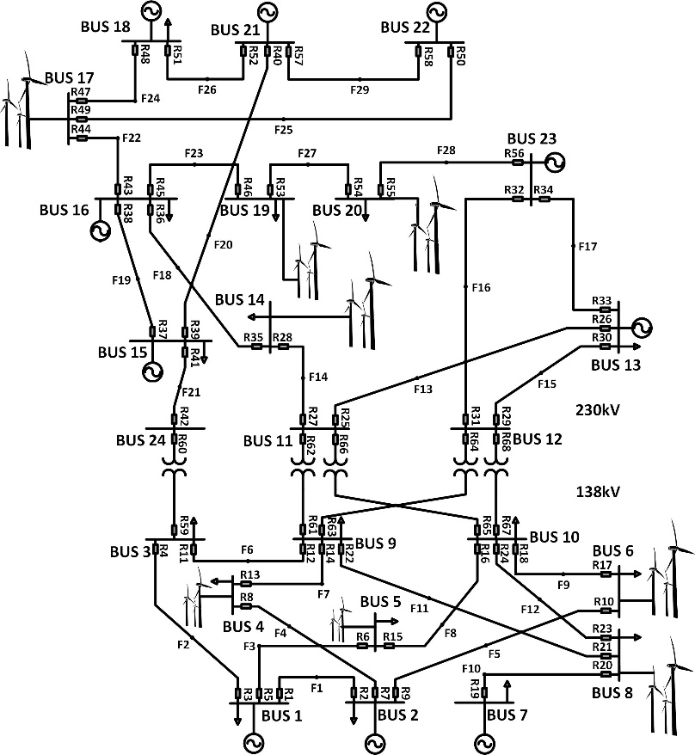

Figure 1. IEEE 24 Bus System

|  |  |  |  |  |  |  |
| --- | --- | --- | --- | --- | --- | --- |
| Relay | IP | ITC | Dual TCV | | | |
|  | (A) | TDS | TDS1 | K1 | TDS2 | K2 |
| 1 | 210 | 0.590 | 0.050 | 0.172 | 0.174 | -0.342 |
| 2 | 240 | 0.531 | 0.050 | 0.088 | 0.171 | -0.497 |
| 3 | 200 | 0.401 | 0.050 | -0.284 | 0.123 | -0.064 |
| 4 | 160 | 0.507 | 0.050 | -0.195 | 0.209 | -0.715 |
| 5 | 500 | 0.417 | 0.050 | -0.260 | 0.100 | 0.152 |
| 6 | 50 | 0.776 | 0.050 | 0.715 | 0.202 | -0.275 |
| 7 | 400 | 0.390 | 0.050 | -0.074 | 0.070 | 0.573 |
| 8 | 160 | 0.505 | 0.050 | -0.050 | 0.147 | -0.354 |
| 9 | 390 | 0.477 | 0.050 | -0.092 | 0.050 | 0.617 |
| 10 | 100 | 0.549 | 0.050 | -0.410 | 0.160 | -0.256 |
| 11 | 160 | 0.466 | 0.050 | 0.007 | 0.176 | -0.587 |
| 12 | 150 | 0.528 | 0.050 | -0.017 | 0.216 | -0.435 |
| 13 | 190 | 0.382 | 0.050 | 0.458 | 0.128 | -0.413 |
| 14 | 470 | 0.448 | 0.050 | -0.251 | 0.144 | -0.312 |
| 15 | 150 | 0.482 | 0.050 | 0.323 | 0.143 | -0.287 |
| 16 | 590 | 0.460 | 0.050 | -0.206 | 0.064 | 0.550 |
| 17 | 50 | 0.929 | 0.050 | 1.095 | 0.243 | -0.198 |
| 18 | 430 | 0.465 | 0.050 | 0.037 | 0.187 | -0.713 |
| 19 | 440 | 0.382 | 0.050 | 1.555 | 0.121 | -0.370 |
| 20 | 1100 | 0.050 | 0.050 | 0.379 | 0.524 | 1.000 |
| 21 | 160 | 0.438 | 0.050 | -0.393 | 0.263 | -0.819 |
| 22 | 50 | 0.687 | 0.050 | -0.300 | 0.117 | 0.808 |
| 23 | 210 | 0.436 | 0.050 | -0.329 | 0.217 | -0.741 |
| 24 | 50 | 0.692 | 0.050 | -0.588 | 0.140 | 0.689 |
| 25 | 70 | 0.644 | 0.050 | -0.033 | 0.210 | -0.512 |
| 26 | 620 | 0.392 | 0.050 | -0.062 | 0.147 | -0.461 |
| 27 | 710 | 0.386 | 0.050 | -0.058 | 0.074 | 0.663 |
| 28 | 550 | 0.338 | 0.050 | -0.173 | 0.086 | -0.054 |
| 29 | 60 | 0.646 | 0.050 | -0.050 | 0.193 | -0.070 |
| 30 | 220 | 0.546 | 0.050 | -0.376 | 0.209 | -0.719 |
| 31 | 70 | 0.690 | 0.050 | -0.138 | 0.185 | -0.036 |
| 32 | 350 | 0.381 | 0.050 | -0.476 | 0.112 | -0.194 |
| 33 | 110 | 0.635 | 0.050 | -0.606 | 0.183 | -0.102 |
| 34 | 180 | 0.475 | 0.050 | -0.627 | 0.232 | -0.648 |
| 35 | 340 | 0.416 | 0.050 | 1.012 | 0.126 | -0.341 |
| 36 | 870 | 0.358 | 0.050 | -0.133 | 0.168 | -0.613 |
| 37 | 480 | 0.459 | 0.050 | 0.459 | 0.129 | -0.174 |
| 38 | 470 | 0.451 | 0.050 | 0.350 | 0.166 | -0.277 |
| 39 | 330 | 0.453 | 0.050 | 0.224 | 0.171 | -0.445 |
| 40 | 360 | 0.476 | 0.050 | -0.591 | 0.155 | -0.349 |
| 41 | 1310 | 0.050 | 0.050 | -0.140 | 0.524 | 1.000 |
| 42 | 190 | 0.412 | 0.050 | 1.304 | 0.104 | 0.204 |
| 43 | 470 | 0.508 | 0.050 | 0.145 | 0.172 | -0.457 |
| 44 | 500 | 0.391 | 0.050 | -0.199 | 0.129 | -0.355 |
| 45 | 1160 | 0.341 | 0.050 | -0.226 | 0.140 | -0.460 |
| 46 | 280 | 0.487 | 0.050 | 1.207 | 0.131 | -0.148 |
| 47 | 620 | 0.410 | 0.050 | -0.129 | 0.102 | 0.233 |
| 48 | 200 | 0.601 | 0.050 | 1.203 | 0.193 | -0.421 |
| 49 | 50 | 0.891 | 0.050 | -0.625 | 0.171 | 0.536 |
| 50 | 310 | 0.372 | 0.050 | 0.694 | 0.113 | -0.281 |
| 51 | 190 | 0.560 | 0.050 | 0.623 | 0.202 | -0.723 |
| 52 | 900 | 0.363 | 0.050 | -0.246 | 0.077 | 0.467 |
| 53 | 970 | 0.288 | 0.050 | -0.293 | 0.061 | 0.588 |
| 54 | 920 | 0.364 | 0.050 | -0.300 | 0.065 | 0.674 |
| 55 | 150 | 0.462 | 0.050 | 1.289 | 0.158 | -0.356 |
| 56 | 1160 | 0.406 | 0.050 | -0.044 | 0.134 | -0.452 |
| 57 | 70 | 0.585 | 0.050 | -0.495 | 0.112 | 0.684 |
| 58 | 260 | 0.416 | 0.050 | 0.652 | 0.157 | -0.564 |
| 59 | 650 | 0.362 | 0.525 | 1.000 | 0.069 | 0.974 |
| 60 | 240 | 0.400 | 0.525 | 1.000 | 0.176 | -0.636 |
| 61 | 310 | 0.454 | 0.525 | 1.000 | 0.132 | -0.083 |
| 62 | 140 | 0.500 | 0.525 | 1.000 | 0.222 | -0.585 |
| 63 | 350 | 0.423 | 0.525 | 1.000 | 0.131 | -0.485 |
| 64 | 130 | 0.509 | 0.525 | 1.000 | 0.209 | -0.515 |
| 65 | 290 | 0.471 | 0.525 | 1.000 | 0.146 | -0.228 |
| 66 | 150 | 0.545 | 0.525 | 1.000 | 0.200 | -0.438 |
| 67 | 350 | 0.427 | 0.525 | 1.000 | 0.125 | -0.431 |
| 68 | 140 | 0.554 | 0.525 | 1.000 | 0.196 | -0.409 |

Table 1: Optimal DOCR Settings for the IEEE 24 bus system

|  |  |  |
| --- | --- | --- |
|  | ITC | Dual TCV |
| Total tripping time | 2637.059 | 587.862 |

Table 2: Total tripping time for the IEEE 24 bus system

# Results and Discussion

Table 1 presents the optimal relay settings of the DOCR governed by the ITC and dual TCV techniques, obtained by solving each PCO respectively. The relay pickup current *Ip* is set to a constant value for both cases, however different TDS values have been found for each DOCR characteristic. The objective of the PCO is to minimize the total tripping time subject to the FRT grid requirement constraint. As seen in table 2, the total tripping time has been improved by 77.7% using the Dual TCV setting which supports the results obtained by Saleh et. Al [5].

# Conclusion

In this project, we aim to find the optimal settings of all DOCRs on an IEEE 24-bus network in a manner that minimizes the total operating time while maintaining FRT grid requirements. DOCR settings are governed by two tripping characteristics: the conventional ITC as well as, the novel dual-TCV proposed in [5]. The latter is found to out perform existing methods by minimizing tripping time by approximately 50%.

# References

[1] M. S. El-Moursi, "Fault ride through capability enhancement for self-excited induction generator-based wind parks by installing fault current limiters," *IET Renewable Power Generation,* vol. 5, *(4),* pp. 269-280, July, 2011.

[2] M. M. Kyaw and V. K. Ramachandaramurthy, "Fault ride through and voltage regulation for grid connected wind turbine," *Renewable Energy,* vol. 36, *(1),* pp. 206-215, 201101, 2011.

[3] K. Saleh *et al*, "Optimal coordination of directional overcurrent relays using a new time-current-voltage characteristic," in *2016 IEEE Power and Energy Society General Meeting (PESGM),* 2016, pp. 1-1.

[4] T. Keil and J. Jager, "Advanced Coordination Method for Overcurrent Protection Relays Using Nonstandard Tripping Characteristics," *IEEE Trans. Power Del.,* vol. 23, *(1),* pp. 52-57, Jan, 2008.

[5] K. A. Saleh, M. S. E. Moursi and H. H. Zeineldin, "A New Protection Scheme Considering Fault Ride Through Requirements for Transmission Level Interconnected Wind Parks," *IEEE Transactions on Industrial Informatics,* vol. 11, *(6),* pp. 1324-1333, Dec, 2015.

# 